**Case Study**

The Avocado Team was tasked to increase feedback given to our recipe creators to promote cooking on our platform. After initial brainstorming, the team has decided to encourage cooks to share their cooking of those recipes in the form of cooksnaps - <https://cookpad.com/uk/cooksnap_intro>

The team would like to tackle this problem by implementing a cooksnap reminder that would solve these user problems:

* As a user, I sometimes forget to send cooksnaps, so I end up not sending it
* As a new user, I don't know what cooksnaps are so after I cook recipes from cookpad, I don't send it
* As a user, I don't understand why I should send cooksnaps so I never do it

**Design**

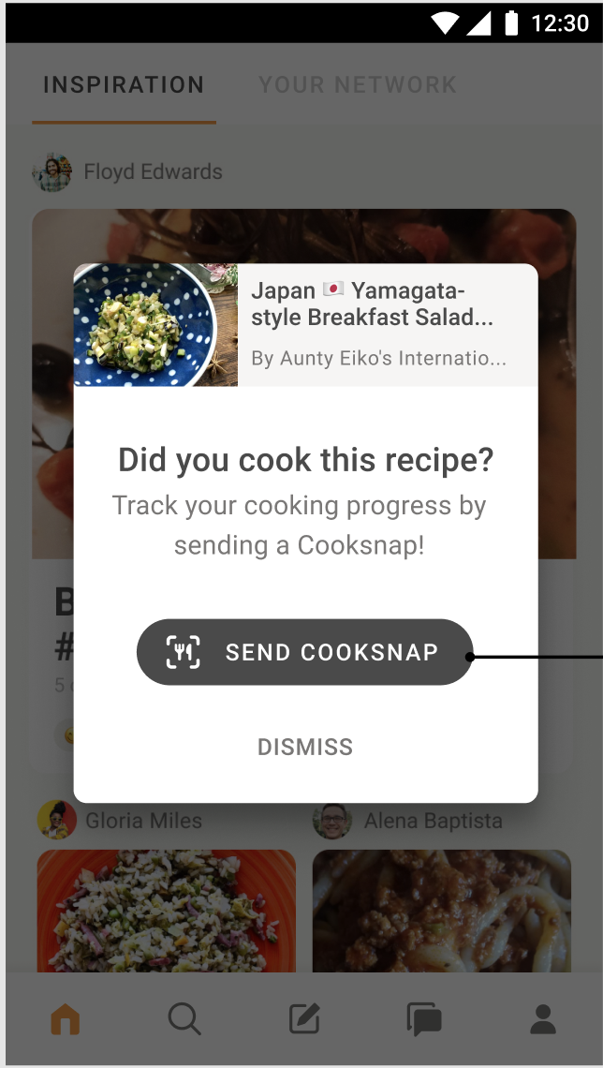

**Problem:**

Now the team knows their focus, and what they want to develop and implement but there are still few missing pieces. This is where your insights come in.

1. Familiarize yourself with the dataset and provide an exploratory analysis which you think is important
2. Based on the data, which recipes do you think should be shown in the reminder (*Please note that a user can open multiple recipes and we don’t want to spam our users with irrelevant content*)
3. When do you think is the best time to show this reminder to a user? (*Please note that you want to show this only once so the timing is important*)
4. How would you test whether your recommendation was successful?

**Data Catalogue:**

Id: *primary key*

user_id: *id of a user performing an action*

recipe_id: *id of a recipe an action is performed on*

event_time: *timestamp of an action (UTC)*

event: *an action*

view_duration: *duration spend on a recipe by a user in seconds*

country: *country where an action happened*

platform: *platform an action was performed on*

ref: *screen where an action was performed on*

via: *a button an action was performed with*

Actions in the event column:

recipe.share: *user shares a recipe*

recipe.edit.open: *user opens a recipe editor*

recipe.add_to_cookplan: *user adds a recipe into their collection of recipes*

recipe.comments.visit: *user opens a comment in the app*

recipe.react: *user gives a reaction to a recipe*

recipe.publish: *user publishes a recipe*

cooksnap.create: *user publishes a cooksnap*

recipe.bookmark: *user bookmarks a recipe*

recipe.cooked_it: *user marks a recipe as cooked*

view_duration: *duration spend on a recipe by user in seconds*

recipe.visit: *user visits a recipe*

cookplan.comments.create: *user creates a comment*

user.follow: *user follows another user*

**Final Output:**

Please, prepare a presentation with no more than 6 slides and attach a link with your visualisations. Preferably use Tableau Viz Tool to analyse the data (you can use the free version of Tableau: https://public.tableau.com/en-us/s/)

Upload your presentation and any other useful documents to the same Google Drive as this document.